Eurofins/Eaton Analytical Laboratories Sampling Procedures

Volatile Organic Contaminants (VOC I)

EPA Method 524.2
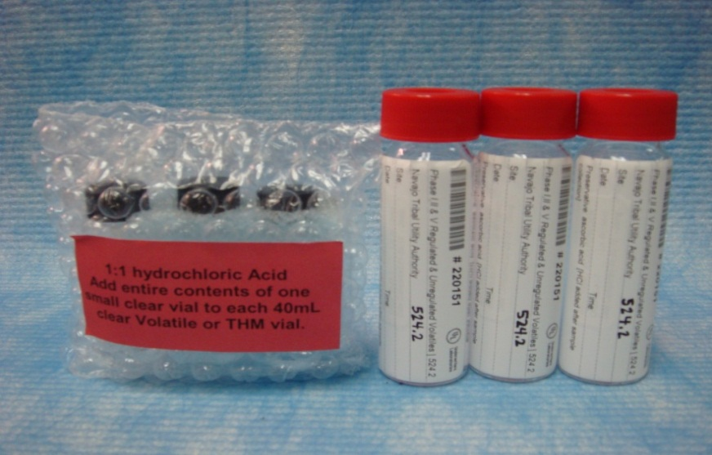

Equipment & Chemicals Needed:
- 3 – 40 ml glass vials with Ascorbic Acid preservative

2 Laboratory Travel Blank (LTB) will have blue labels.

3 Hydrochloric Acid (1:1 HCl) vials
- Ice chest with ice
- Nitrile gloves

Holding Time: 14 days

Procedure:
- Flush the well line for 5 minutes immediately prior to sampling.
- Chain of custody and labels must match and be complete: collection date & time, PWSID #, Well #, system name and sampler name.
- Slow the water stream before collection.
- Take one of 40 ml vial & fill half with sample.
- Add entire contents of one small clear vial of 1:1 HCl to each 40 ml vial. CAUTION: Handle glass vial with care: HCl is a very strong acid.
- Carefully fill the rest of the glass vial to the top with sample creating a dome-like shape over the top of the vial. NOTE: Do not overfill; each vial contains Ascorbic Acid preservative.
- Carefully cap and close the glass vial.
- Invert the glass vial to check for air bubbles. If there are no air bubbles package the vial and place on ice and keep at 4° C.
- If air bubbles present, carefully open the vial (right side up) and add a few drops of sample. Recap the vial and check for air bubbles until all air is eliminated.
Repeat this step until there are no air bubbles.
- Repeat steps 4-7 for the other 40 ml glass vials.
- Submit samples to NTUA Laboratory within 24-48 hours
NOTE: Laboratory Trip Blank (LTB) will have blue labels & already filled. DO NOT OPEN. The purpose of the Travel Blank is to determine if there was exposure to any contaminates during collection or while in transit.

EDB & DBCP (VOC II),

EPA Method 504.1
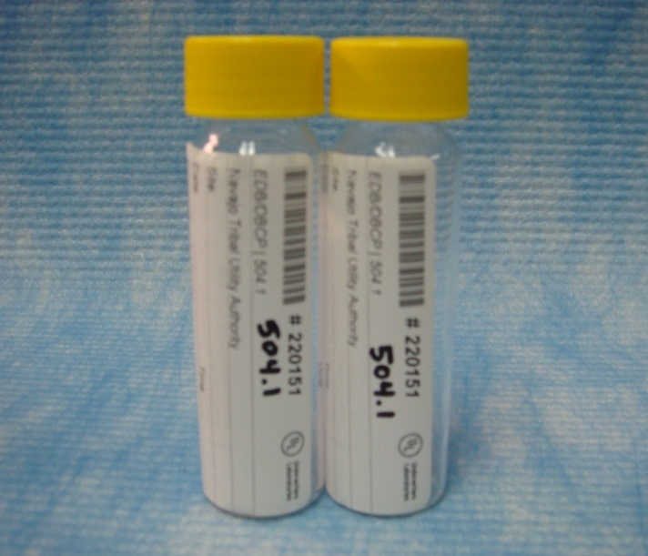

Equipment and Chemicals Needed:
- 2 – 40 ml clear glass vials with Sodium Thiosulfate (Na2S2O3)
- 1 Laboratory Trip Blank (LTB)
- Ice chest with ice
- Nitrile gloves

Holding Time: 14 days

Procedure:

- Flush the well line for 5 minutes immediately prior to sampling.
- Chain of custody and labels must match and be complete: collection date & time, PWSID #, Well # & system name, sampler name.
- Slow the water stream before collection.
- Fill the 40-ml glass vial to the top with sample, creating a dome-like shape above the top of the vial. NOTE: Each vial contains Sodium Thiosulfate, do not overfill.
- Carefully cap and close the glass vial. Invert the glass vial to check for air bubbles. If there are no air bubbles, secure & package the vial and place on ice. Keep sample at 4° C.
- If air bubbles present, carefully open the vial (right side up) and add a few drops of sample. Recap the vial and check for air bubbles until all air is eliminated.
- Repeat steps 4-6 for remaining vials.
- Submit samples to NTUA Lab within 24-48 hours.
NOTE: Laboratory Trip Blank (LTB) will have blue labels & already filled. DO NOT OPEN. The purpose of the Travel Blank is to determine if there was exposure to any contaminates during collection or while in transit.

Carbamates,
EPA Method 531.2

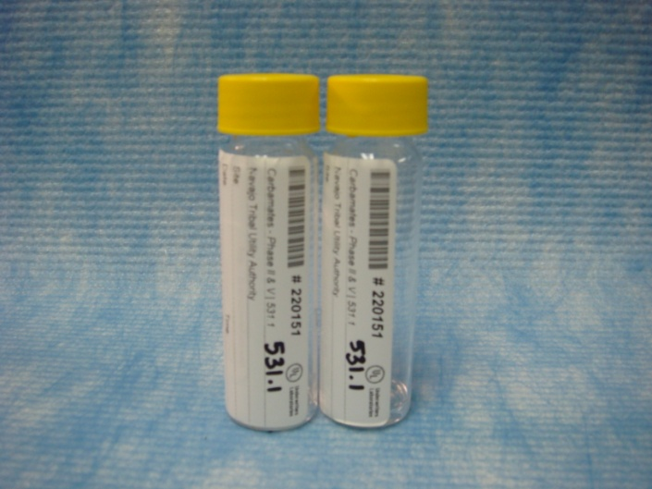

Equipment & Chemicals Needed:

- 2 – 40 ml amber glass vials w/ Sodium Thiosulfate & Potassium dihydrogen citrate
- Ice chest with ice
- Nitrile gloves

Holding Time: 28 days

Procedure:

- Flush the well line for 5 minutes immediately prior to sampling.
- Chain of custody and labels must match and be complete: collection date & time, PWSID #, Well # & system name and sampler name.
- Slow the water stream before collection.
- Fill a 40 ml glass vial to the top with sample, creating a dome-like shape above the top of the vial. NOTE: DO NOT overfill; each vial contains Sodium Thiosulfate & Potassium dihydrogen citrate.
- Carefully cap and close the glass vial. Invert the glass vial to check for air bubbles. If there are no air bubbles, secure & package the vial and place on ice. Keep sample at 4°C.
- If air bubbles present, carefully open the vial (right side up) and add a few drops of sample. Recap the vial and check for air bubbles until all air is eliminated.
- Repeat steps 4-6 for remaining vials.
- Submit samples to NTUA Lab within 24-48 hours.

Synthetic Organic Compounds (SOCs) and Pesticides

EPA Method 525.2

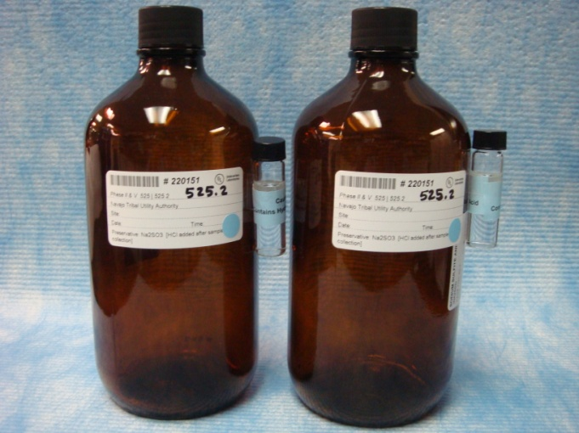

Equipment and Chemicals Needed:

- 2 – 1 L Amber Glass Bottles with Sodium Sulfite
- 2 – 4 ml Hydrochloric Acid (HCl) vials
- Ice chest with ice
- Nitrile gloves

Holding Time: 14 Days

Procedure:
- Flush the well line for 5 minutes immediately prior to sampling.
- Chain of custody and labels must match and be complete: collection date & time, PWSID #, Well #, system name and sampler name.
- Slow the water stream before collection.
- Fill the 1 liter glass bottle to the neck of the bottle with sample and gently shake for approximately one minute.
- Add the 4 ml HCl preservative vial to the bottle. NOTE: DO NOT overfill; each bottle contains Sodium Thiosulfate
- Cap the bottle and put on ice.
- Repeat step 4 – 6 for second bottle.
- Submit samples to NTUA Lab within 24-48 hours.

PCB,

EPA Method 505

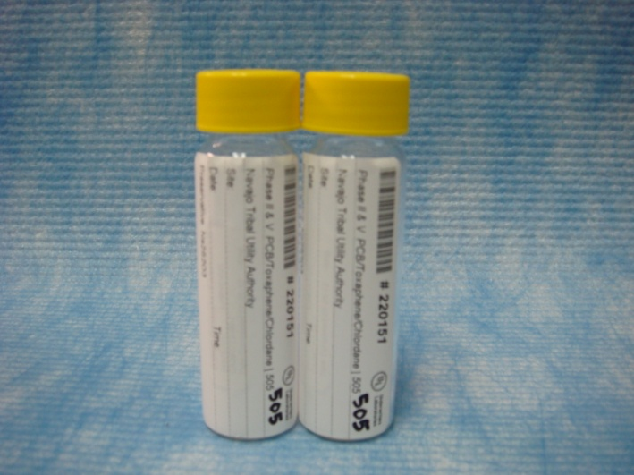

Equipment and Chemicals Needed:

- 2 –40 mL clear glass vials with Sodium Thiosulfate
- Ice chest with ice
- Nitrile gloves

Holding Time: 14 Days

Procedure:

- Flush the well line for 5 minutes immediately prior to sampling.
- Chain of custody and labels must match and be complete: record collection date & time, PWSID #, Well #, system name and sampler name.
- Slow the water stream before collection.
- Fill the 40 mL glass vial to the top with sample,, creating a dome-like shape above the top of the vial. NOTE: Do NOT overfill; each vial contains Sodium Thiosulfate.
- Carefully cap and close the glass vial. Invert glass vial to check for air bubbles, if there are no air bubbles, then secure and package the vials and samples place on ice, keep sample at 4° C.
- If air bubbles present, carefully open the vial (right side up) and add a few drops of sample. Recap the vial and check for air bubbles until all air is eliminated.
- Repeat steps 4-6 for second vial.
- Submit samples to NTUA Lab within 24-48 hours.

Acid Herbicide, Chlorinated Acids

EPA Method 515.3

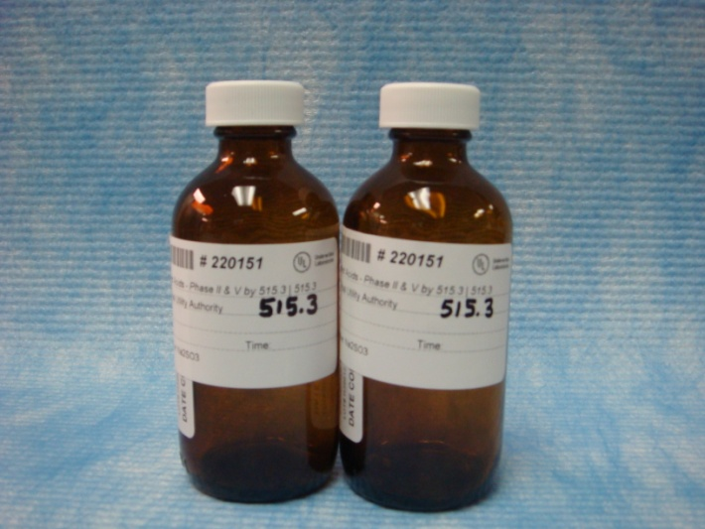

Equipment and Chemicals Needed:

- 2 – 120 mL bottles with Sodium Sulfite
- Ice Chest with ice

Holding Time: 14 Days

Procedure:

- Flush the well line for 5 minutes immediately prior to sampling.
- Chain of custody and labels must match and be complete: record collection date & time, PWSID #, Well #, system name and sampler name.
3. Slow the water stream before collection.
4. Fill the bottle to the top with sample, do not overflow.
Note: Each bottle contains Sodium Sulfite.
- Carefully cap the glass bottle and place on ice.
- Keep sample at 4°C.
- Repeat steps 4-6 for the second bottle.
- Submit samples to NTUA Lab within 24-48 hours.

Cyanide,

EPA 335.4

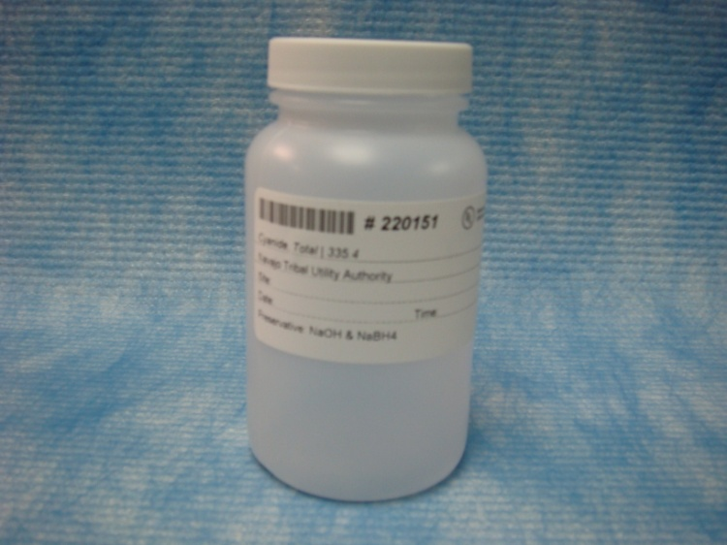

Equipment & Chemicals Needed:

- 1 - 250 ml Plastic bottle with Sodium Hydroxide (NaOH) & NaBH₄
- Ice Chest with ice
- Nitrile Gloves

Holding Time: 14 Days

Procedure:

- Flush the well line for 5 minutes immediately prior to sampling.
- Chain of custody and labels must match and be complete: record collection date & time, PWSID #, Well #, system name and sampler name.
3. Slow the water stream before collection.
- Fill the container with sample and be cautious not to overflow. NOTE: Bottle contains sodium hydroxide; DO NOT rinse out or spill the preservative in the container.
- Put the sample on ice. Keep sample at 4°C.
- Submit sample to NTUA Lab within 24-48 hours.

Total Organic Carbon

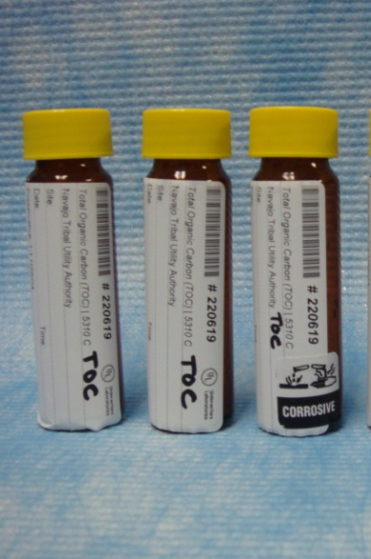

Equipment and Chemicals Needed:

- 3 – 40 ml Amber Vials with 1:1 sulfuric acid
- Ice chest
- Ice
- Nitrile gloves

Holding Time: 28 Days

Procedures:

- Flush the sampling point for 10 minutes immediately prior to sampling.
- Chain of custody and labels must match and be complete: record collection date & time, PWSID #, Well #, system name, sampler name.
- Fill a 40 mL glass vial to the top with sample, creating a dome-like shape above the top of the vial. NOTE: Do not overfill or rinse out; each vial is pre-filled with a 1:1 sulfuric acid.
- Carefully cap and close the glass vial. Invert the glass vial to check for air bubbles. If there are no air bubbles, secure & package the vial and place on ice. Keep sample at 4° C.
- Repeat steps 3 – 5 for remaining vials.
- Submit samples to NTUA Lab within 24-48 hours.

NOTE FOR MEXICAN HAT WTP: Three (3) vials are for raw water and three (3) vials are for finished water. To determine the removal rate, both raw and finished samples must be collected at the same time (or close to it as possible).

Eurofins/Analytical Laboratories Sampling Procedures

SPECIAL ORGANICS (Dioxin, Diquat, Endothall and Glyphosate)

Dioxin, EPA Method 1613

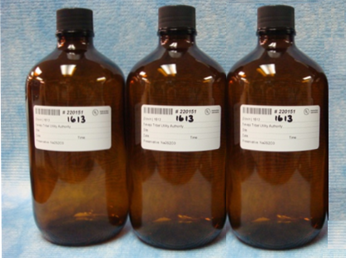

Equipment & Chemicals Needed:

- 3 – 1L amber glass bottles, Preservative Sodium Thiosulfate (Na₂S₂O₃₎
- Ice chest
- Ice
- Nitrile Gloves

Holding Time: 30 days

Procedure:

- Flush out the well/line for 5 minutes.
- Write the collection date, collection time, PWSID #, Tribal well # and system name on the labels and fill out the Chain of Custody.
- Fill the 1-L amber glass bottles to the neck.
- Cap the bottle and put on ice, repeat step for other containers. Keep samples at 4° C.
- Submit samples to NTUA Lab within 24-48 hours.

Diquat, EPA Method 549.2

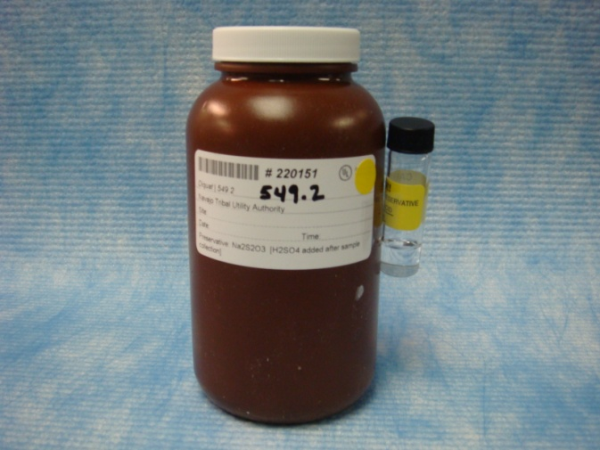

Equipment & Chemicals Needed:

- 500 mL polypropylene amber bottle with Sodium Thiosulfate
- 1 – 1:1 H₂SO₄ vial
- Ice chest
- Ice
- Nitrile gloves

Holding Time: 7 days

Procedures:

- Flush the well line for 5 minutes immediately prior to sampling.
- Fill out chain of custody and labels, both must match and be completed: collection date, collection time, PWSID #, Tribal well #, system name and sampler name. Note: Each bottle contains Sodium Thiosulfate, do not attempt to rinse out bottle.
- Fill the 1 L bottle to the neck of the bottle (do not overflow) and the 1:1 H₂SO₄ acid vial to the water sample.
- Cap the bottle and put on ice. Keep sample at 4° C.
- Submit samples to NTUA Laboratory within 24-48 hours.

Endothall, EPA Method 548.1

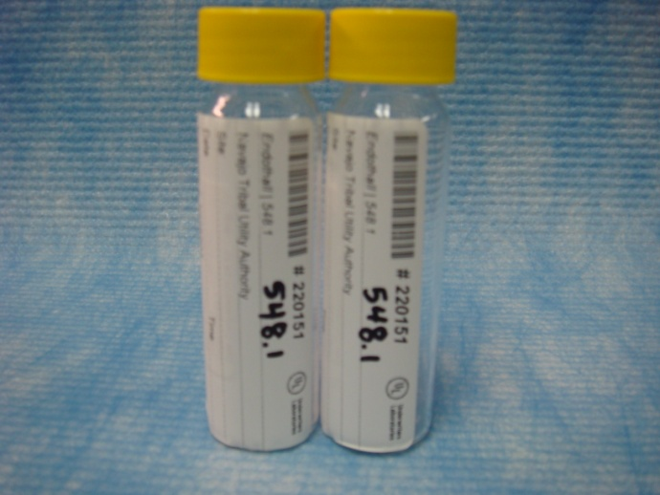

Equipment & Chemicals Needed:

- 2 – 40 mL clear glass vials, preservative is Na₂S₂O₃
- Ice chest
- Ice
- Nitrile gloves

Holding Time: 7 days

Procedures:

- Flush out well/line for 5 minutes.
- Write the collection date, collection time, PWSID #, Tribal well # and system name on the labels and fill out the Chain of Custody.
- Fill the 40 mL glass vial to the top with water, creating a dome-like shape above the top of the vial.
- Carefully cap and close the glass vial. Invert the glass vial to check for air bubbles, if there are no air bubbles, then secure and package the vials and samples place on ice, keep sample at 4° C.
- Repeat steps 3 – 4 for the second vial.
- Submit samples to NTUA Lab within 24-48 hrs.

Glyphosate, EPA Method 547

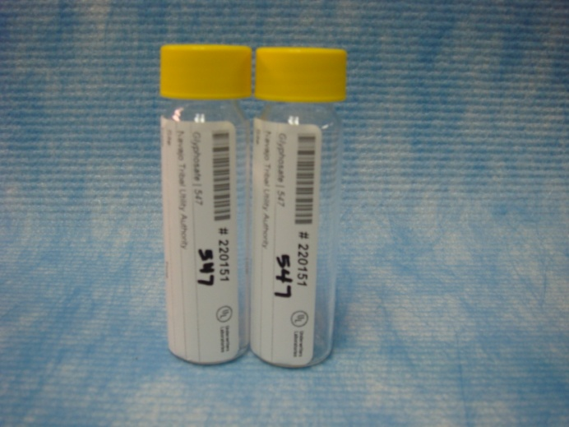

Equipment & Chemicals Needed:

- 2 – 40 mL clear glass vials with Sodium Thiosulfate (Na₂S₂O₃)
- Ice Chest
- Ice
- Nitrile gloves

Holding Time: 14 days

Procedures:

- Flush out well/line for 5 minutes.
- Write the collection date, collection time, PWSID #, Tribal well # and system name on the labels and fill out the Chain of Custody.
- Fill the 40 mL glass vial to the top with water, creating a dome-like shape above the top of the vial. Note: Each bottle contains Na₂S₂O₃, do not rinse out or overflow.
- Carefully cap and close the glass vial. Invert the glass vial to check for air bubbles, if there are no air bubbles, then secure and package the vials and samples place on ice, keep sample at 4° C.
- Repeat steps 3 – 4 for the second vial.
- Submit samples to NTUA Lab within 24-48 hours.

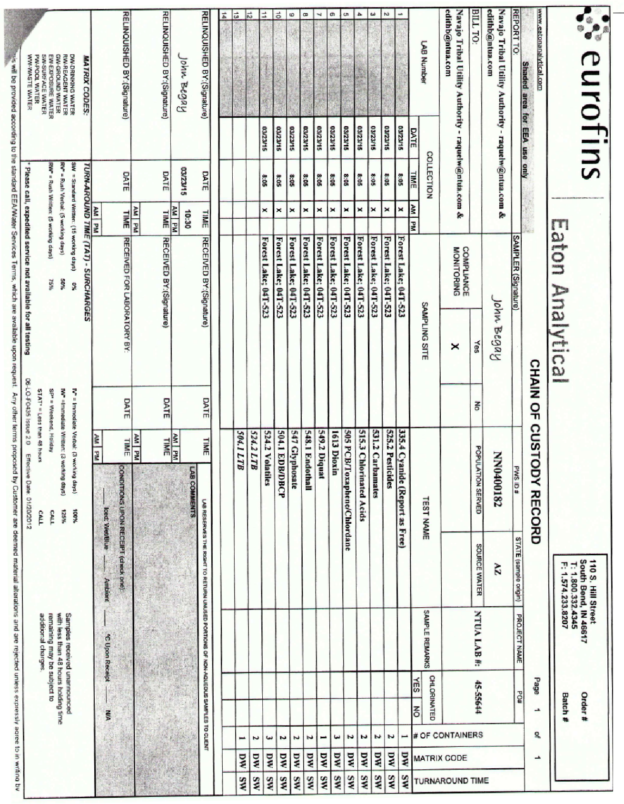
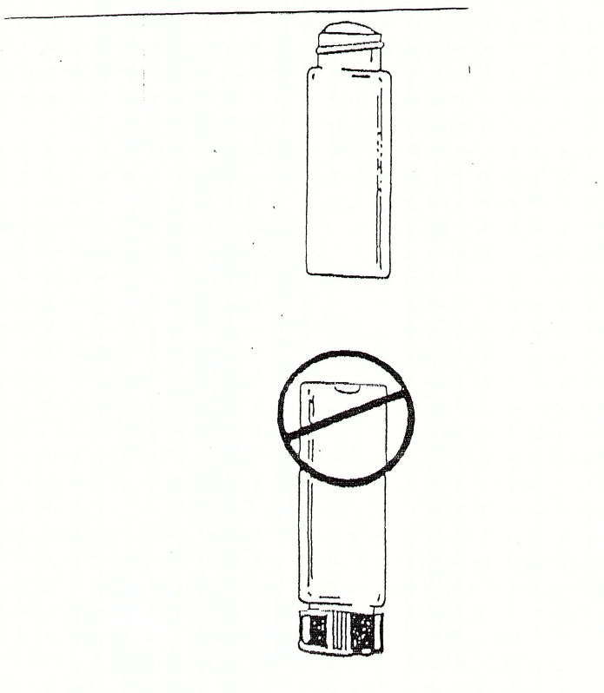

LEGEND LABORATORY SAMPLING PROCEDURES

Total Trihalomethanes (TTHMs), EPA Method 524

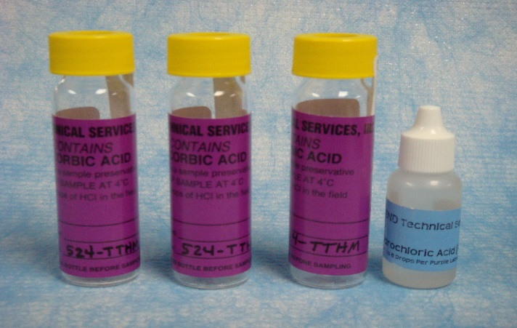

Equipment and Chemicals Needed:

3 -- 40-ml Glass vials w/sodium thiosulfate (_{purple labels})
- Hydrochloric Acid (HCl) dropper bottle
- Ice chest with ice
- Nitrile gloves

Holding Time: 14 days

Procedure:

- Flush the well line for 5 minutes immediately prior to sampling. NOTE: The sample must be collected at the end of the line at maximum residence time from a customer’s home.
- Chain of custody and labels must match and be complete: collection date & time, PWSID #, Well # & system name, customer name and sampler name.
- Slow the water stream before collection.
- Fill the 40-ml glass vial halfway.
- Add 5 drops of HCl to vial and continue to fill to top with sample, creating a dome-like shape above the top of the vial. NOTE: Each vial contains Sodium Thiosulfate, do not overfill.
- Cap and close the glass vial. Invert the glass vial to check for air bubbles. If there are no air bubbles, secure & package the vial and place on ice. Keep sample at 4°C.
- If air bubbles present, carefully open the vial (right side up) and add a few drops of sample. Recap the vial and check for air bubbles until all air is eliminated.
- Repeat steps 4-7 for remaining vials.
- Submit samples to NTUA Lab within 24-48 hours.

Haloacetic Acids (HAA5), EPA Method 552

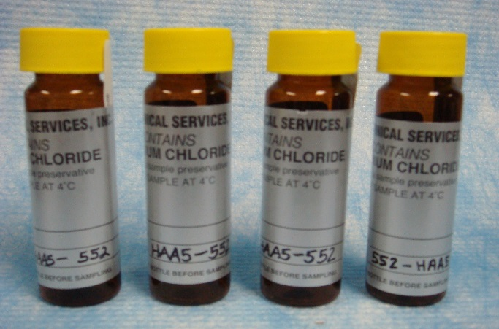

Equipment and Chemicals Needed:

4 -- 40-ml Amber Glass Vials w/ ammonium chloride preservative (_{silver labels})

Ice chest and ice
- Nitrile Gloves

Holding Time: 28 days

Procedure:

- Flush the line for 5 minutes immediately prior to sampling. NOTE: The sample must be collected at the end of the line at maximum residence time from a customer’s home.
- Chain of custody and labels must match and be complete: collection date & time, PWSID #, Well # & system name, customer name and sampler name.
- Carefully fill the glass vial to the top with water creating a dome-like shape over the top of the vial. NOTE: Do not overflow and flush the preservative already present in vial.
- Cap and close the glass vial. Invert the glass vial to check for air bubbles. If there are no air bubbles, secure & package the vial and place on ice. Keep sample at 4°C.
- If air bubbles present, carefully open the vial (right side up) and add a few drops of sample. Recap the vial and check for air bubbles until all air is eliminated.
- Repeat steps 3-5 for remaining vials.
- Submit samples to NTUA Lab within 24-48 hours.

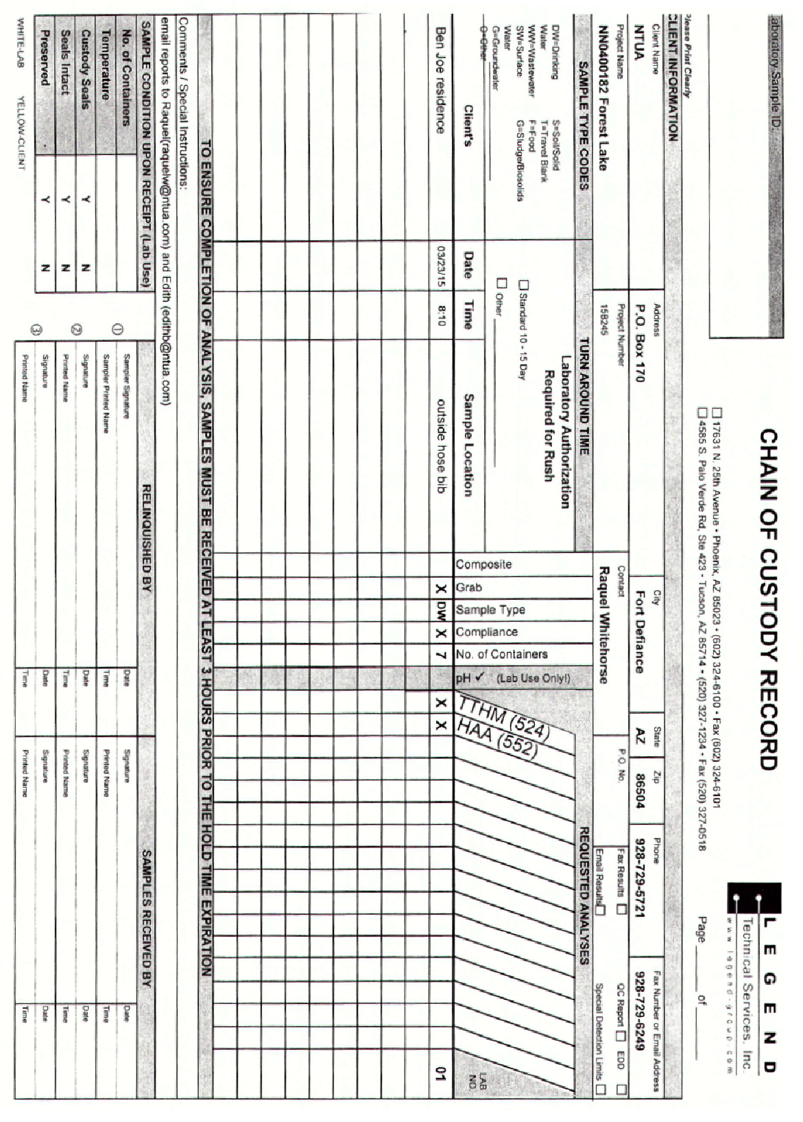

RADIATION SAFETY SAMPLING PROCEDURES

Radionuclides

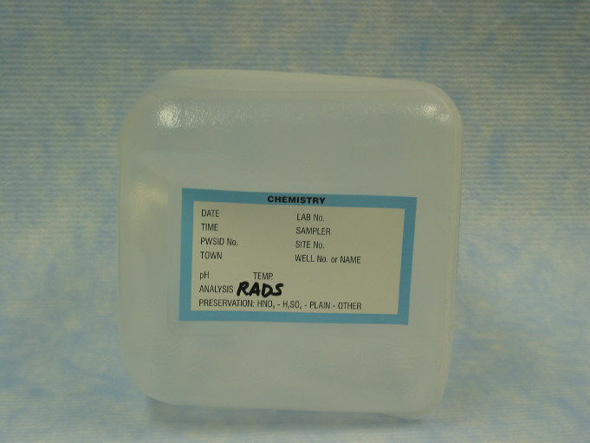Equipment and Chemicals Needed:

1-gallon cubitainer

Holding Time: 6 months

Procedure:

- Flush the well line for 5 minutes immediately prior to sampling.
- Fill out the label and the NTUA Chain of Custody. Write the collection date, collection time, PWSID#, Tribal Well #, and system name and sampler name.
- Carefully fill the 1-gallon cubitainer to the curvature/shoulder with sample.
- Place sample on ice and ship to the laboratory.
- Submit sample to NTUA Laboratory within 24-48 hours.

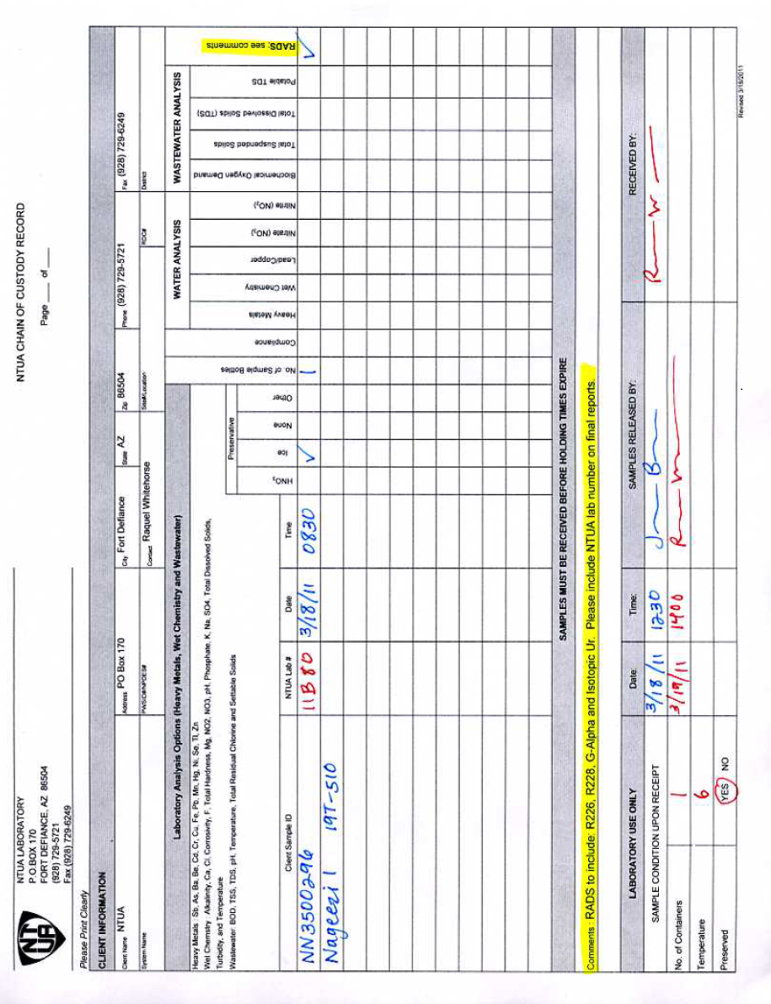

FIBERQUANT SAMPLING PROCEDURES

Asbestos EPA Method 100.1

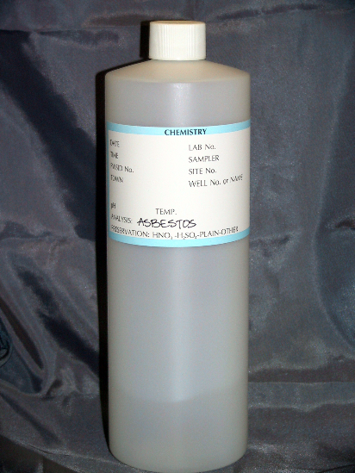

Equipment and Chemicals Needed:
- 1 – 1 L plastic bottle (preservative NONE)
- Ice chest with ice
- Nitrile Gloves
- Waterproof Ink/sharpie pen

Holding Time: 48 Hours

Procedures:

- Prior to sampling, ensure Asbestos piping is present where sampling is to occur. Flush for 5 minutes immediately prior to sampling. Note: SAMPLE NEEDS TO BE COLLECTED FROM DISTRIBUTION SYSTEM, NOT THE WELL. IT IS SUFFICIENT TO COLLECT FROM A METER YOKE OR A BLOW OFF FROM THE MAINLINE
- Chain of custody and labels must match and be complete: collection date & time, PWSID #, Well #, system name and sampler name.
- Slow the water stream before sampling.
- Fill the 1-L container with sample.
- Submit sample to NTUA Laboratory within 24 hours.

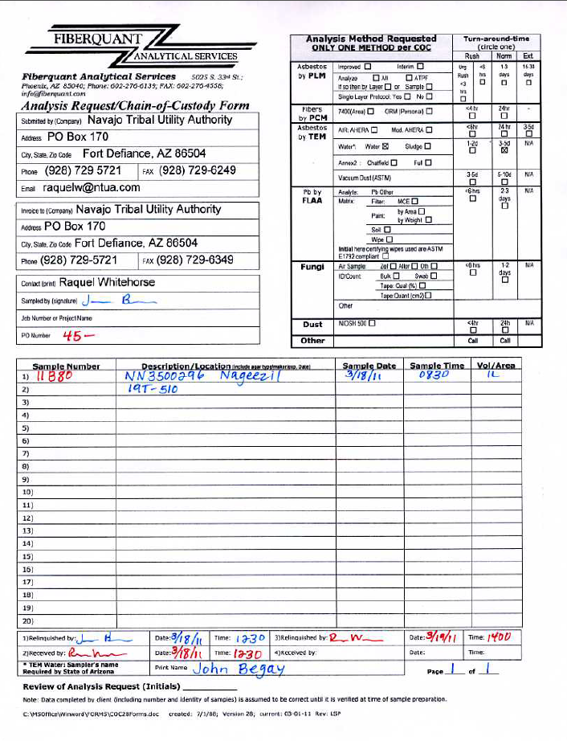
Apex Environmental Sampling Procedures

Heavy Metals, EPA 200.8

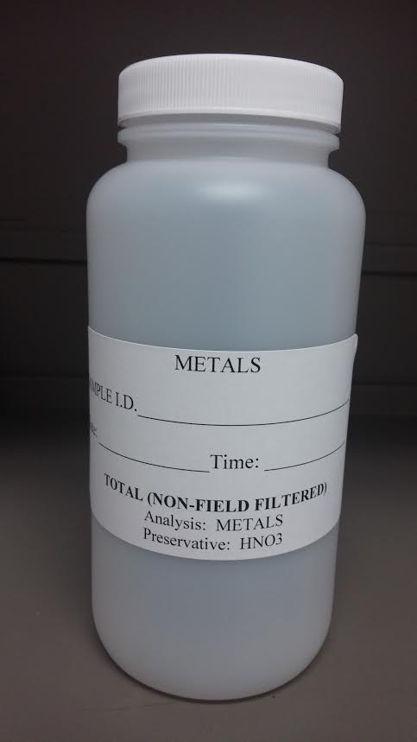

Equipment and Chemicals Needed:
- 1– 500 mL bottle with Nitric Acid preservative
- Ice Chest with ice
- Nitrile Gloves
- Waterproof ink/sharpie pen

Holding Time: 6 months

Procedure:
- Flush the line for 5 minutes immediately prior to sampling.
- Slow the water stream before collection.
- Complete chain of custody and labels must match: collector’s name, client name, sample site, date and time of collection, sample type, comments about the sample (if applicable) PWSID #, Tribal Well # & system name.
- Fill the bottle to the top, do not overflow. Note: Each bottle contains nitric acid preservative.
- Carefully cap the plastic bottle and place on ice.
- Keep sample at 4-6° C.
- Submit samples to NTUA Laboratory within 24-48 hours

Fluoride, Chloride, Sulfate, Phosphate, Nitrite, Nitrate, SM 300.0

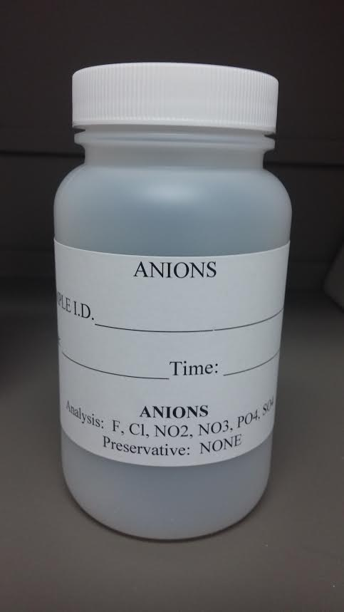

Equipment & Chemicals Needed:
- 1 - 250 ml plastic bottle
- Ice Chest with ice
- Nitrile Gloves
- Waterproof Ink/sharpie pen

Holding Time: 48 hours (NO2^{-,} NO3^{-,} PO4⁻)
28 days (Fl⁻, Cl⁻, SO4⁻)

Procedure:
- Flush the line for 5 minutes immediately prior to sampling.
- Slow the water stream before collection.
- Complete chain of custody and labels must match: collector’s name, client name, sample site, date and time of collection, sample type, comments about the sample (if applicable) PWSID #, Tribal Well # & system name.
- Fill the container and be cautious not to overflow.
- Put the sample on ice. Keep sample at 4-6°C.
- Submit sample to NTUA Laboratory within 24-48 hours.



