Using the NTUA Laboratory Web Server to View and Obtain Sample Results

Revised 10/03/2007

Written By
Marvin Shorty
Chemist
Navajo Tribal Utility Authority
Table of Contents

- Introduction pg. 3

- Accessing Your Account pg. 4

- Viewing Your Results pg. 7

- Bacti and Fluoride Counts pg. 17

- Downloading Your Results pg. 19

- Using the Search Engine pg. 21

- Customized Formats pg. 23

- Logging Out of Your Account pg. 29

- Appendix A pg. 30

Introduction

Welcome to NTUA Web Services!

This new service provided by the NTUA Laboratory will enable you to view and obtain sample results through the Internet. Useful demographic and analytical information pertaining to your sample will be posted in a format that is easy to understand and view. Sample results for both Drinking and Wastewater results will be posted every other business day.

To use this service you will need to be able to connect to the NTUA network, and have a web browser to view the website. Microsoft Excel is necessary to download results. As of this printing, to access the NTUA Web Server points your web browser to the following address, http://limsws.ntua.com/. The laboratory will contact you if this address changes.

The overall goal is to provide a service that is accurate and user friendly. Appendix A, located at the end of this manual, defines all column headings related to sample demographics.

Accessing Your Account

The NTUA Laboratory will assign you an account ID and Password to view your results. Once you direct your browser (Internet Explorer) to the web server’s Main Menu you should see an image similar to Figure 1.

Figure 1. Default page for Web Server
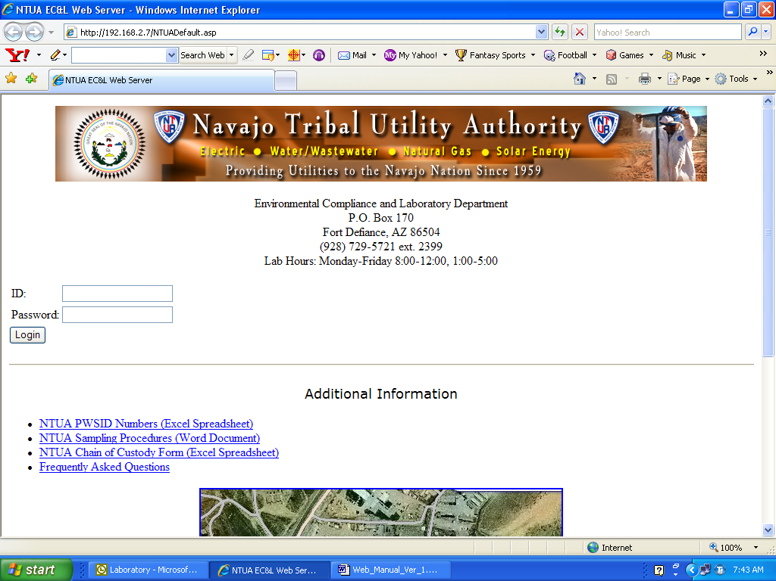

Type in your `ID:` and `Password:` and click the `Login` button to access your account. The NTUA Laboratory will provide you with this information. If you do not have this information contact the Laboratory at (928) 729-5721 extension 2399.

You will also notice links for additional information on the Main Menu. To access this information simply click on the link. There is also a link to access a page for `Frequently Asked Questions`. Before contacting the Laboratory for questions please visit this page.
Accessing Your Account

Once logged in you should see an image similar to Figure 2. NTUA districts will have additional buttons at the top of the page to track Bacteriological and Fluoride sampling counts.

Figure 2. First page viewed once account is accessed.
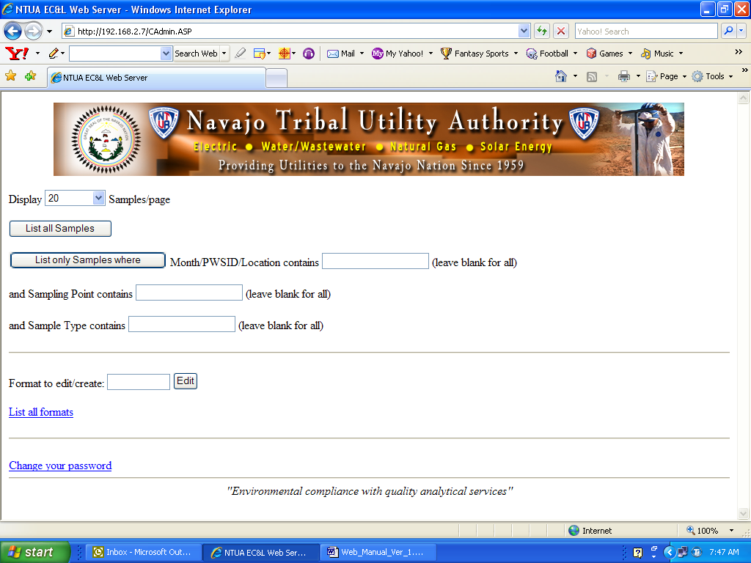

The number of results displayed on one page is controlled by a drop down list `Display xx Samples/page`, located near the top of the page. See Figure 3 to view the options for this drop down list.

The `List all Samples` button will list all sample results with respect to number selected from the `Display xx Samples/page` drop down list. The `List all Samples` will be covered in the following section.

The web server is equipped with a search engine to help you view results for a specific sample. The search engine procedure will be covered later.

Accessing your account

Figure 3. Drop down list to control the number of sample results displayed per page.
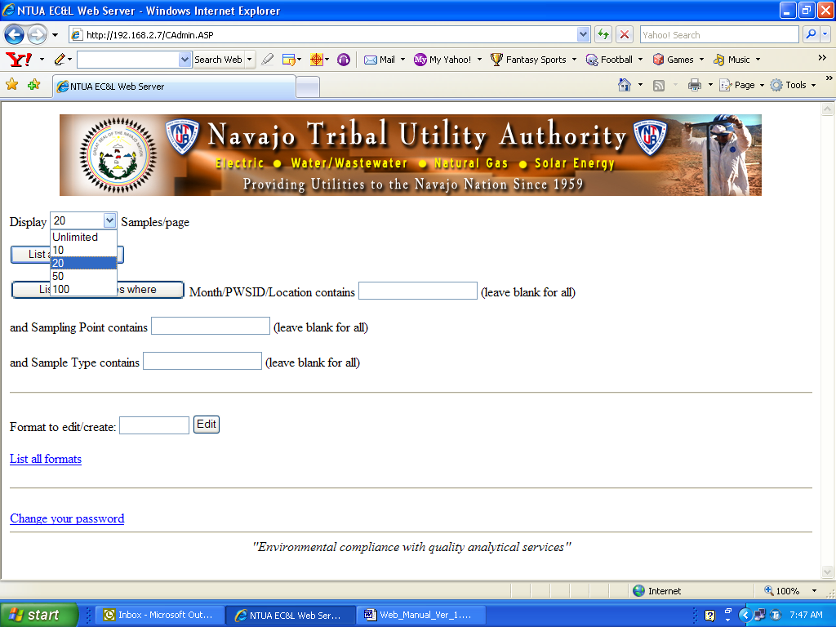

Viewing Your Results

Once you have decided on the number of samples to be displayed click the `List all Samples` button. You should see an image similar to Figure 4.

Figure 4. List all Samples page
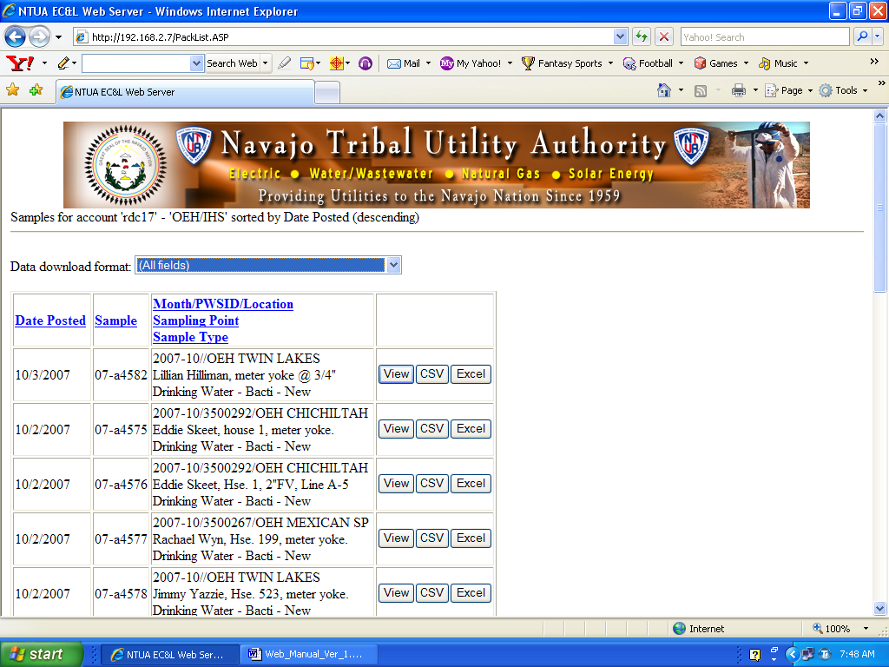

The samples can be sorted by five parameters. The parameters are listed below with a short description for each.

Date Posted | This date corresponds to the date the sample results were posted by the laboratory.
Sample | This is the sample identification number assigned by the laboratory.
Month/Location | The month, PWSID, and location of where the sample was collected. The date format is Year-Month. The PWSID format is the 9 digit assigned by EPA. The location is the name of the water system
Sampling Point | The format is Customer’s name or facility, point of collection.
Sample Type | The type of sample. Drinking Water. Wastewater.

Viewing Your Results

Each of the parameters can be sorting in ascending or descending order by simply clicking on the parameter. Only in descending order will the text `(descending)` appear at the top right of the page next to your account name.

The sample types are divided into several categories. These are listed below.

Drinking Water – Bacti | Bacteriological Drinking Water, otherwise known as `Bacti`.
Drinking Water – Bacti - New | Bacteriological Drinking Water results for new customers only.
Drinking Water – Inorganics | Drinking Water with Inorganic results. Example results are Heavy Metals and Wet Chemistry.
Drinking water – Lead/Copper | Drinking Water samples designated as Lead and Copper samples
Drinking Water – NO3NO2 | Drinking Water with Nitrate (NO₃) and Nitrite (NO₂) results.
Drinking Water – Other | Drinking Water with results other than those listed above. This sample type pertains to samples sent to contract labs for analysis. Yearly and quarterly compliance samples for water wells are assigned this sample type.
Wastewater | Wastewater samples.

Viewing Your Results

As mentioned earlier the samples can be sorted by one of the five parameters. The following figures show samples sorted by the parameters mentioned.

Figure 5. Samples sorted by Sample Type in ascending order.
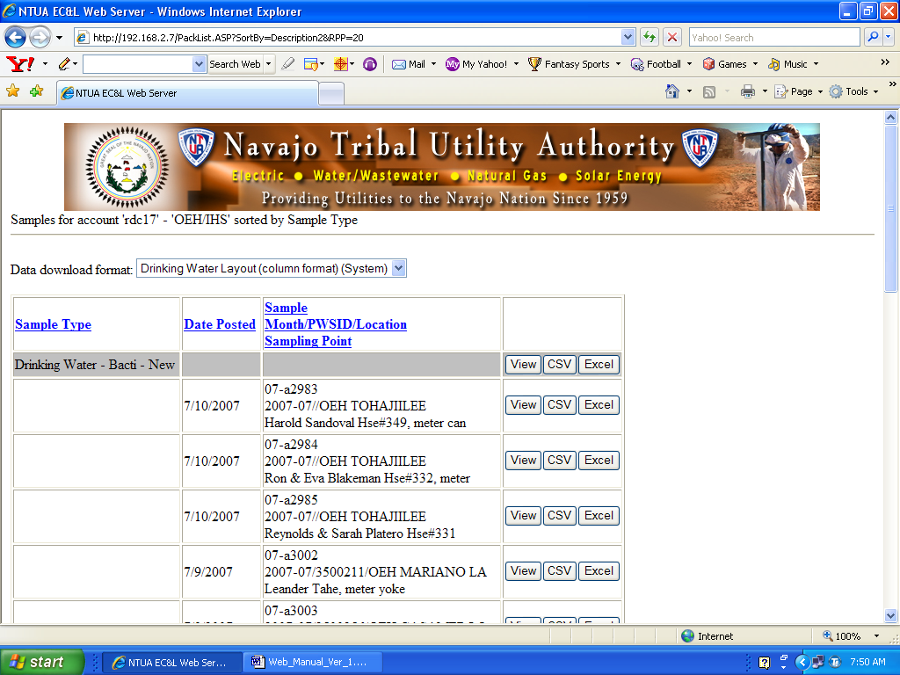

The second line of text on the web page clearly states which parameter the samples are sorted by. Here the parameters are sorted by Sample Type in ascending order. The `Data download format:` will be discussed later. To view all the samples designated as `Drinking Water – Bacti` simply click the view button that is located in the same row shaded in gray. This is true for all other parameters where a view button is present in the same row as the parameter.

Viewing Your Results

Figure 6. Samples sorted by Sample in ascending order.
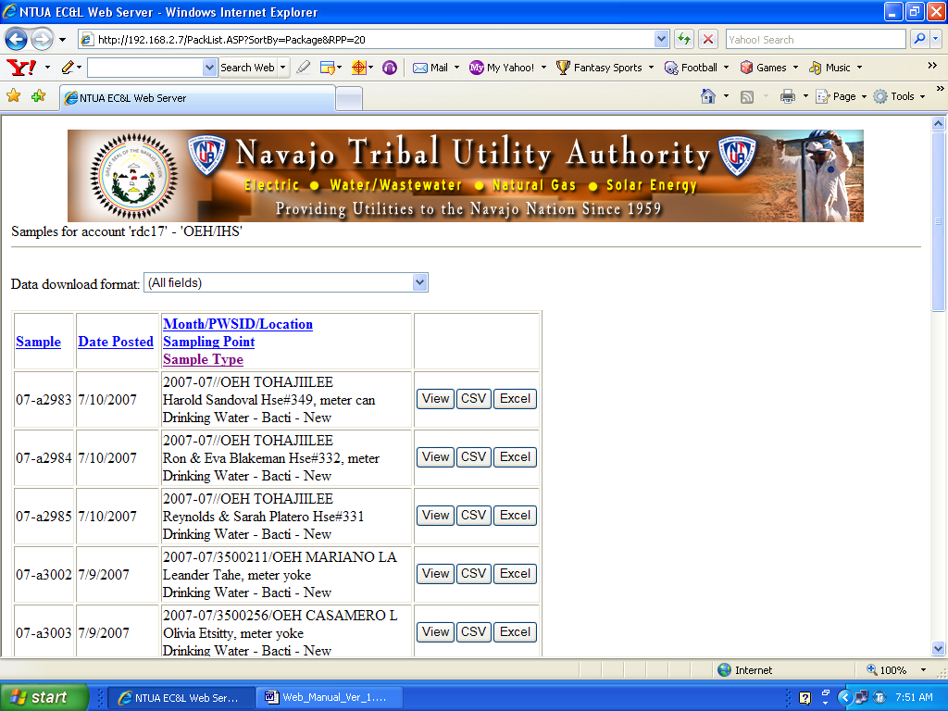

The page is sorted by the Sample (Sample ID) parameter in ascending order. To change to descending order, simply click on the `Sample` link. The Sample, or Sample ID, is assigned by the laboratory.

Viewing Your Results

Figure 7. Samples sorted by Sampling Point in ascending order.
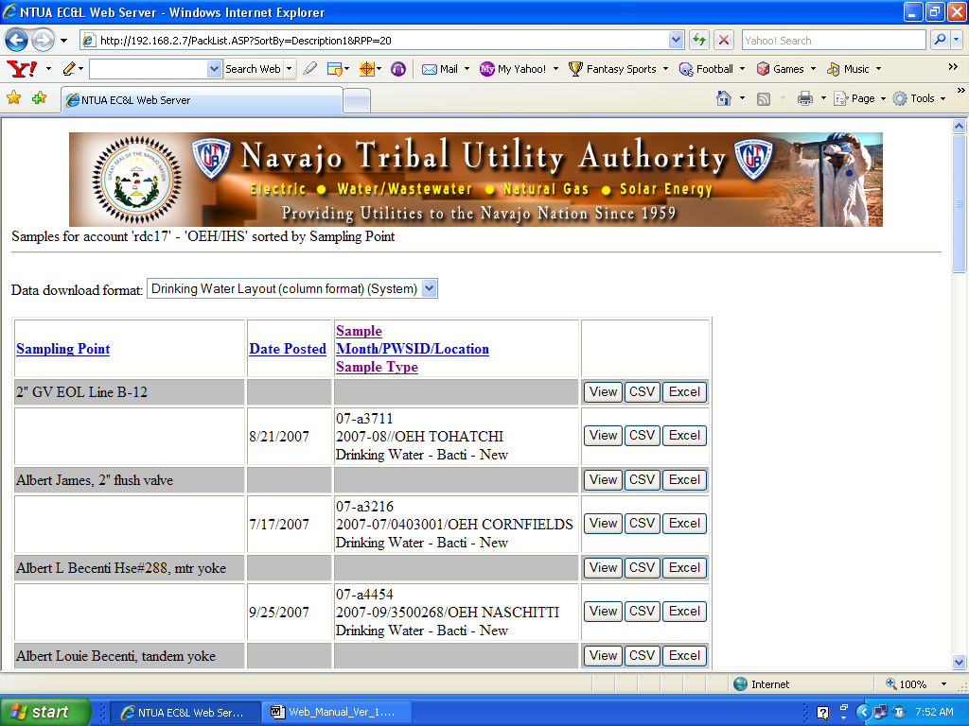

The image above shows the samples sorted by Sampling Point. The web browser sorts by the first letter in the Sampling Point field. If you would like to search for a customer with the last name beginning with `B` you would have to use the web browser’s search engine for a more time efficient search. This will be discussed later.
Viewing Your Results

Figure 8. Samples sorted by Month/PWSID/Location in ascending order
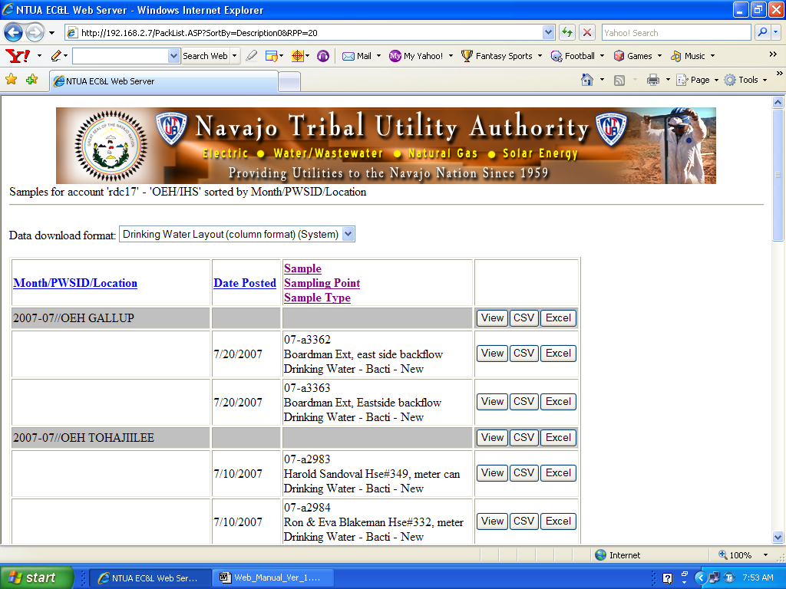

The Month/PWSID/Location parameter sorts the samples by the Year-Month since it is the first data type in this parameter. It then sorts by PWSID then Location.

Viewing Your Results

The `Data download format:` will be discussed in this section. Pre-made formats will be used as examples. User customized formats will be discussed in a later section.

The `Data download format: ` offers the viewer to display results in several different formats or layouts. Figure 9 shows the choices currently available and the table following it discusses each format.

Figure 9. Data download formats currently available.
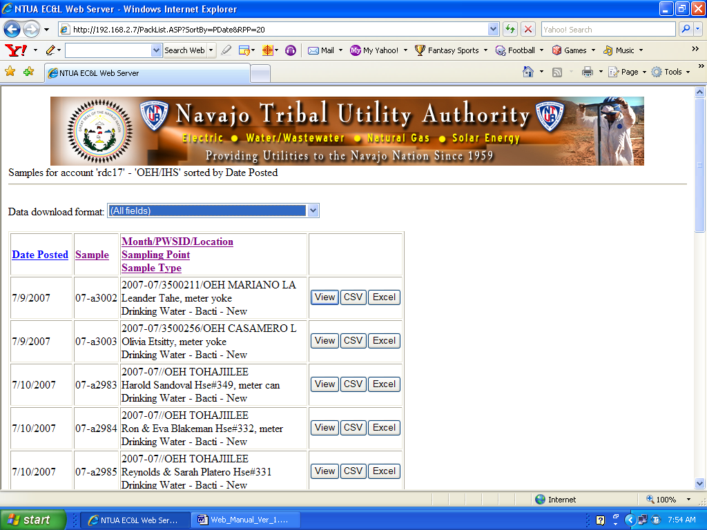

Viewing Your Results

The section below briefly discusses each format. These are the minimum number of formats available. Each user can add a customized format.

All Fields | Returns all fields currently tracked by the web server. Some fields may not pertain to the sample type.
Drinking Water layout – column format | A system format displaying fields relevant to Drinking Water samples. All sample results are displayed in one column.
Drinking Water layout – row format | A system format displaying fields relevant to Drinking Water samples. Each sample result is displayed one row at a time.
Compliance Status | A system format displaying fields relevant to Compliance Bacti samples. A quick view to see your sample status.
Wastewater layout – column format | A system format displaying fields relevant to Wastewater samples. All sample results are displayed in one column.
Wastewater layout – row format | A system format displaying fields relevant to Wastewater samples. Each sample result is displayed one row at a time.

Viewing Your Results

Figure 10 shows Drinking Water – Bacti samples sorted by sample type and in Drinking Water Column layout.

Figure 10.
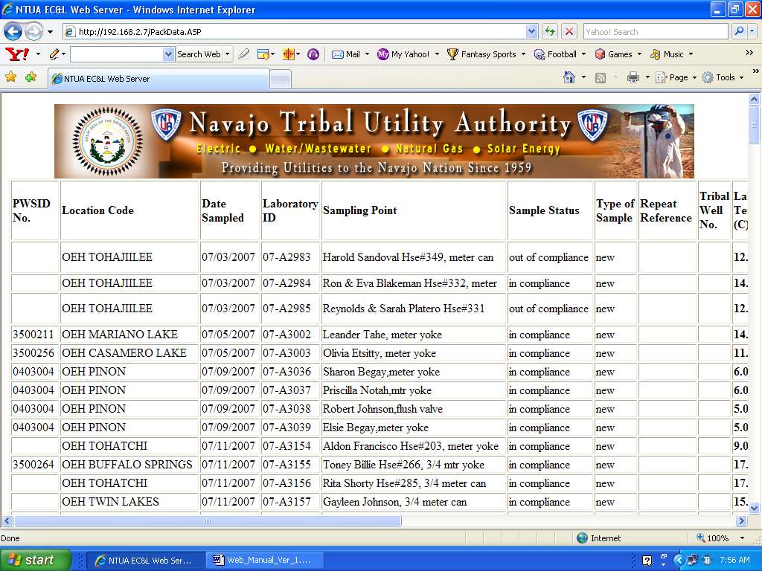

To view your sample results similar to the above image first sort the samples by Sample Type. If the sorting is done in ascending order you should see `Drinking Water – Bacti` as the first Sample Type. Next select the `Drinking Water layout column layout` format from the drop down list and click the `view` button located in the same row as the `Drinking Water – Bacti` sample type.

Viewing Your Results

To view one sample in one of the formats simply select the format from the drop down list and click the view button associated with the sample. Figure 11 shows viewing one sample with the `Compliance Status` format.

Figure 11.
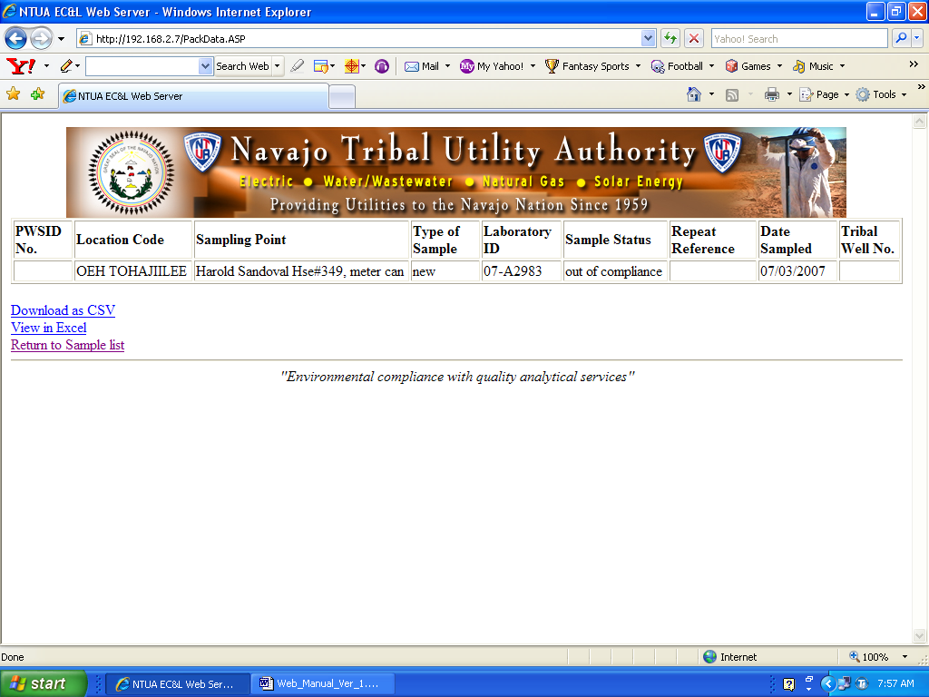

To view all Wastewater samples in the Wastewater layout (column) format perform the following procedures:

- Select the `List all Samples` button, from the main menu.
- Sort samples by `Sample Type`
- Locate the Wastewater samples by either scrolling the page or searching different pages.
- Select `Wastewater layout – column format` from the drop down list for data download format.
- Select the view button

Bacteriological and Fluoride Counts

The Web Server is capable of tracking the number of monthly Bacti and Fluoride samples needed for each water system. This feature is only available f or NTUA districts. When logged in to a NTUA District account you should see an image similar to Figure 12.

Figure 12.
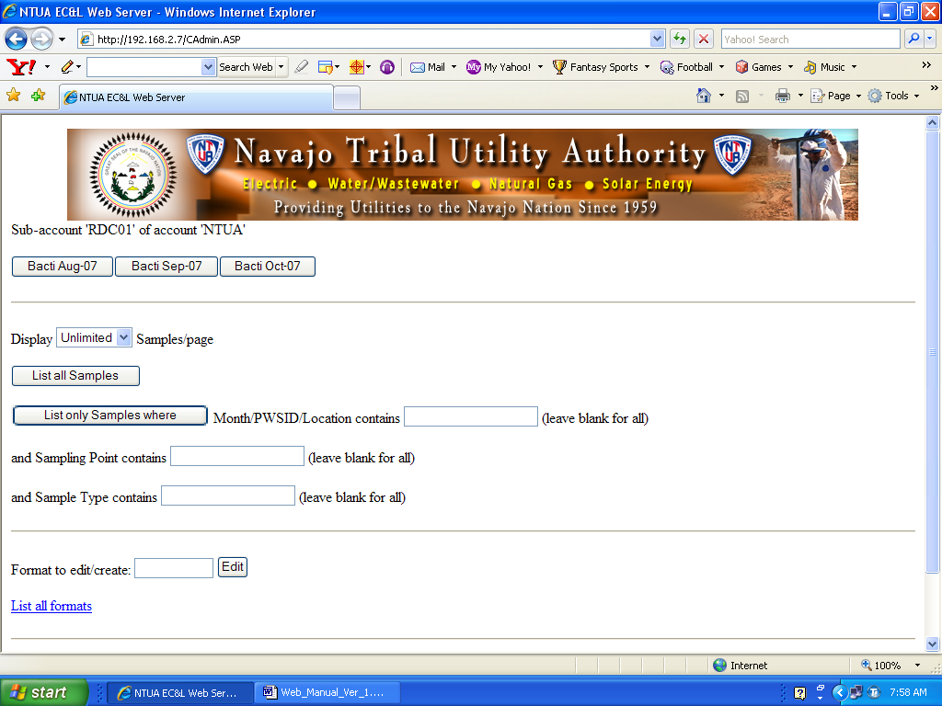

The Bacti and Fluoride reports are divided into months. To access a month simply click on any of the buttons labeled `Bacti Month-Year` near the top of the web page.

Bacteriological and Fluoride Counts

Figure 13.
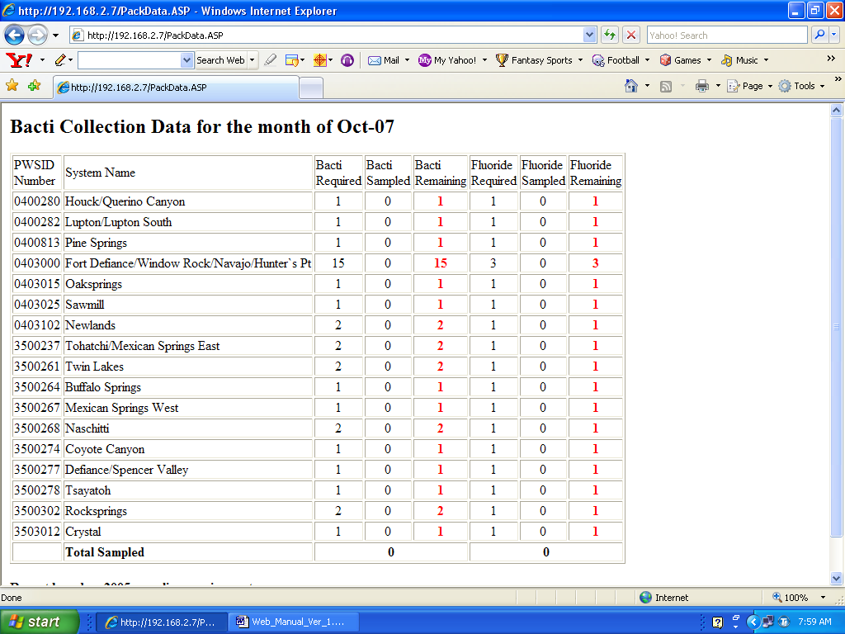

The Bacti and Fluoride monthly report is shown above in Figure 13. The report displays the PWSID Number, System Name and counts for Bacti and Fluoride samples for each system. The `Required` field is the number of samples needed for that water system. The `Sampled` field is a count of the number of samples that have been analyzed and reported as completed. Bacti and Fluoride samples with pending results will not appear in this field. The `Remaining` field is the difference of the `Required` and `Sampled` fields. The `Remaining` field will appear bold and red if the number is not equal to zero.

Important Note:
Samples are included in the count until the sample is labeled as completed, or reportable.
Downloading Results

Each account has the ability to download data directly from the web server. Data can be downloaded for each sample or sample type. The formats in which the data can be downloaded are: Comma Separated Values (CSV) and Excel. Figure 14 shows one sample downloaded in CSV format.

Figure 14. Downloading results in CSV format.
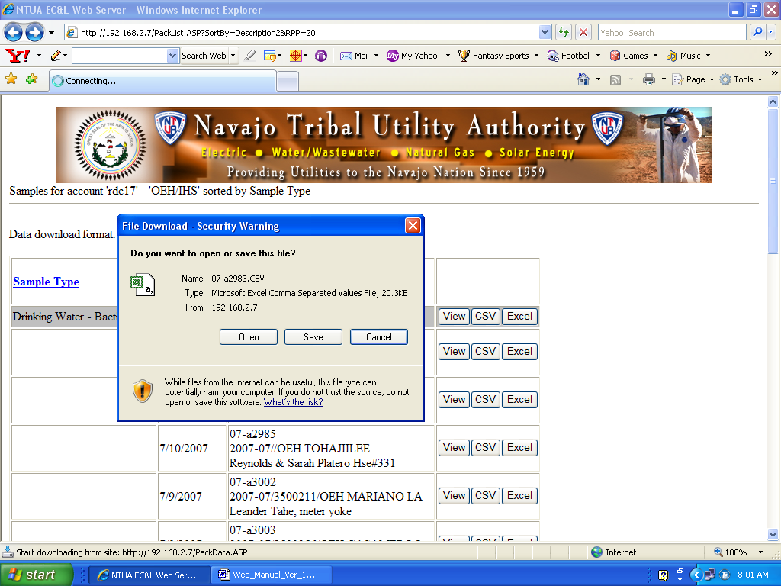

Figure 15 shows data downloaded directly into an Excel spreadsheet. To save the Excel spreadsheet simple select save as from the File menu in the top left corner. This is shown in Figure 16.

Downloading Results

Figure 15. Downloading results directly into Excel
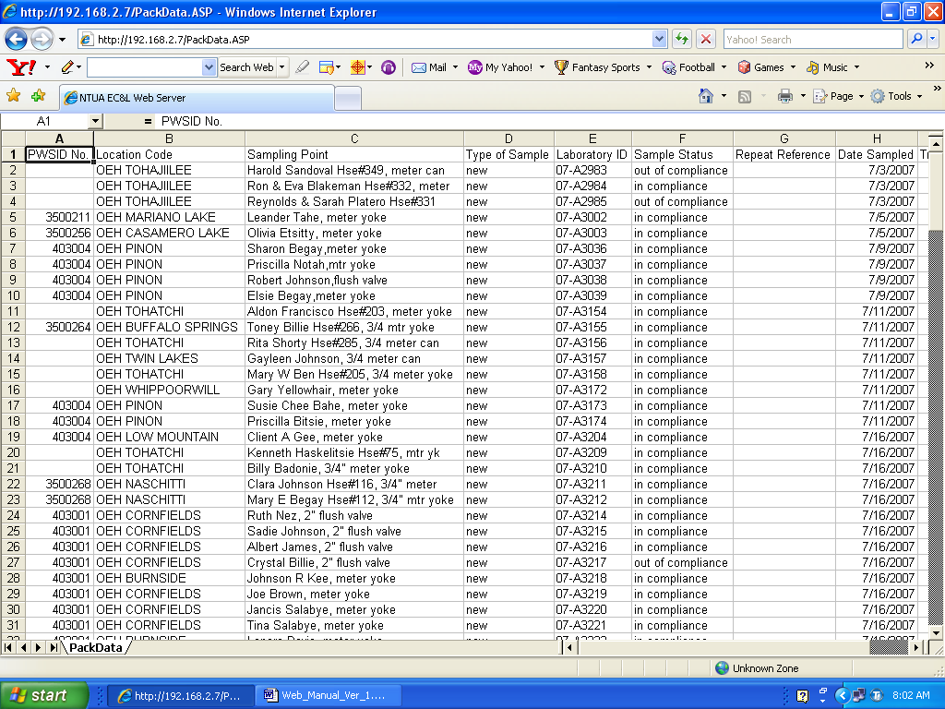

To download the results into an Excel spreadsheet you must have Microsoft Excel installed on your computer.

Figure 16. Saving the Excel file.
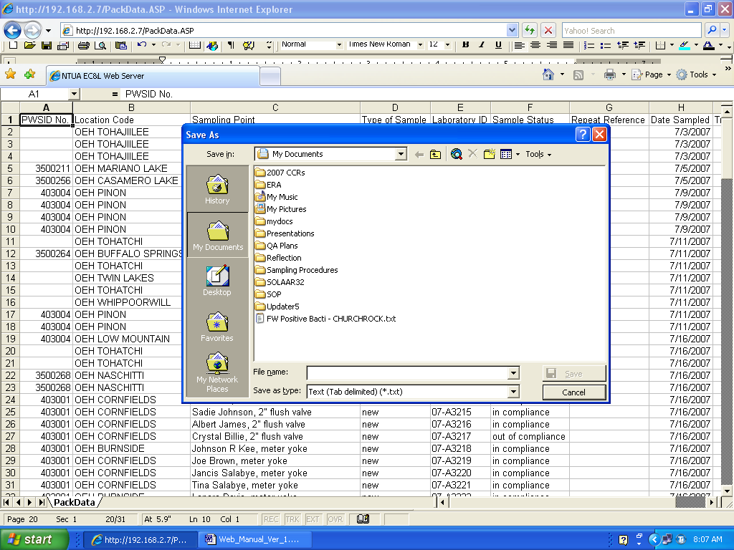

Once the file is saved you can perform manipulations of the data in Excel like you normally would.

Using the Search Engine

The web browser is capable of searching for results using several parameters. Listed below are the parameters that can be used for searching.

Month/PWSID/Location | YYYY-MM/1234567/System Name
Sampling Point | Customer Name or facility, point of collection
Sample Type | Type of sample

To search for a sample that was collected in March 2005, with a PWSID# of 0403000 and collected from the Navajo system, type in the information in the search box for `Month/PWSID/Location`. The forward slashes must also be included if the search is to be done using all three data types. Figure 17 shows the values inputted for this search. Once this information is typed in select the `List only Samples where` button.

Figure 17. Searching with the Month/PWSID/Location parameter

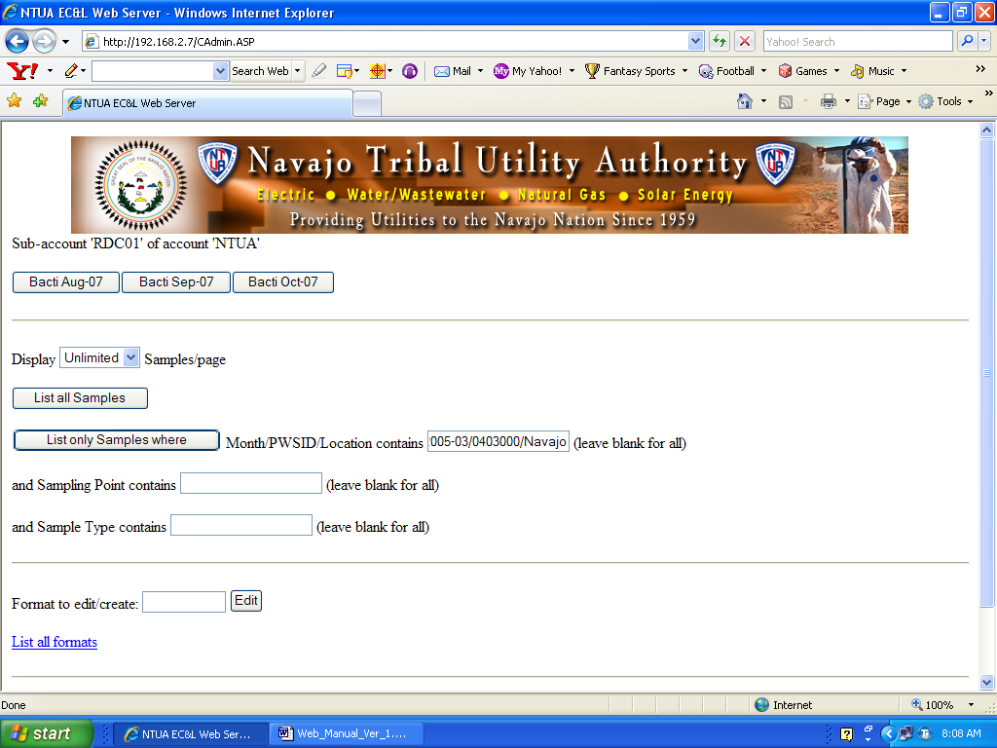

Using the Search Engine

To search for a Bacti sample that was collected from a customer with the last name Yazzie, enter Yazzie in the Sampling Point box and Bacti in the Sample Type box. Figure 18 shows the parameters to be searched.

Figure 18. Searching for a Bacti sampling with a sampling point containing Yazzie.
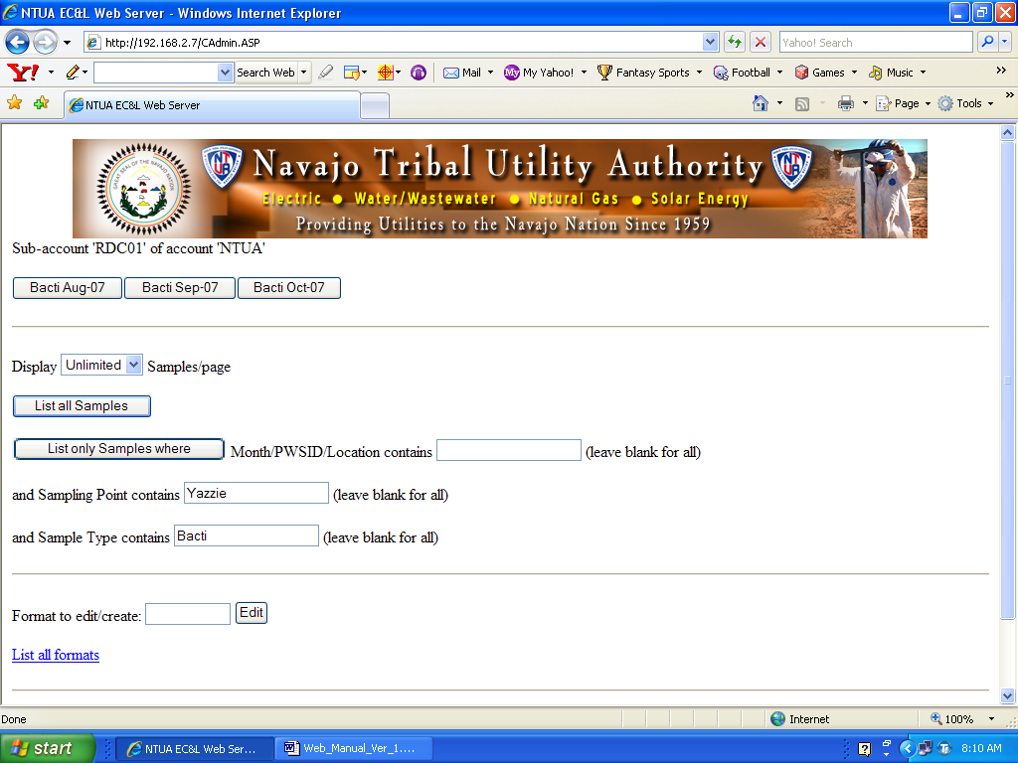

To search for all Bacti samples collected in February 2005 simply type 2005-02 in the Month/PWSID/Location field and Bacti in the Sample Type field. Select the `List only Samples where` button to begin your search.

To search for all samples in a particular water system simply type in the 7-digit number assigned to the water system. This is the number assigned by the EPA without the two-letter prefix. If your water system has the following EPA identification, NN0403000, search by only using the numbers assigned, 0403000.

Customized Formats

As mentioned earlier you can customize the layout for your sample results. This feature is very useful if you would like to view only certain fields associated with your sample. To set up a customized format follow this procedure.

- On the lower left corner of the web page locate `Format to edit/create: `. You must be logged in to use this feature. Type in a name for the new format in the box located next to `Format to edit/create: `.

Figure 19.
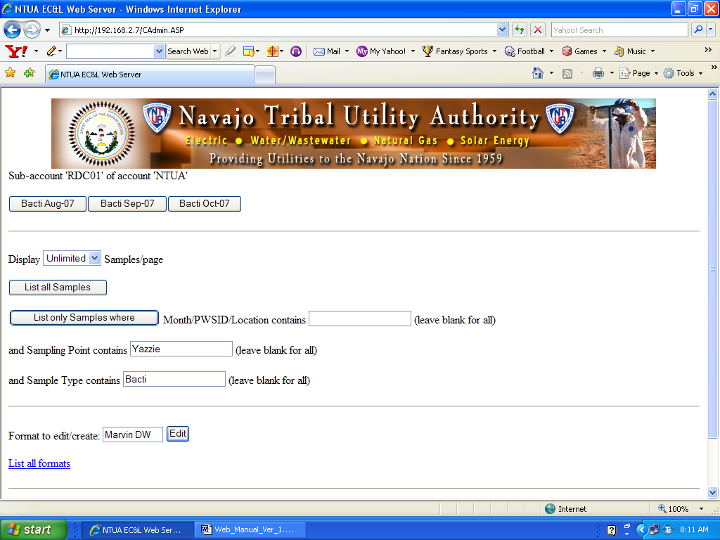

- Once you have decided on a name click the `Edit` button.

Customized Formats

- A figure similar to the one below should now be visible. Type in a Description for your new format.

Figure 20.
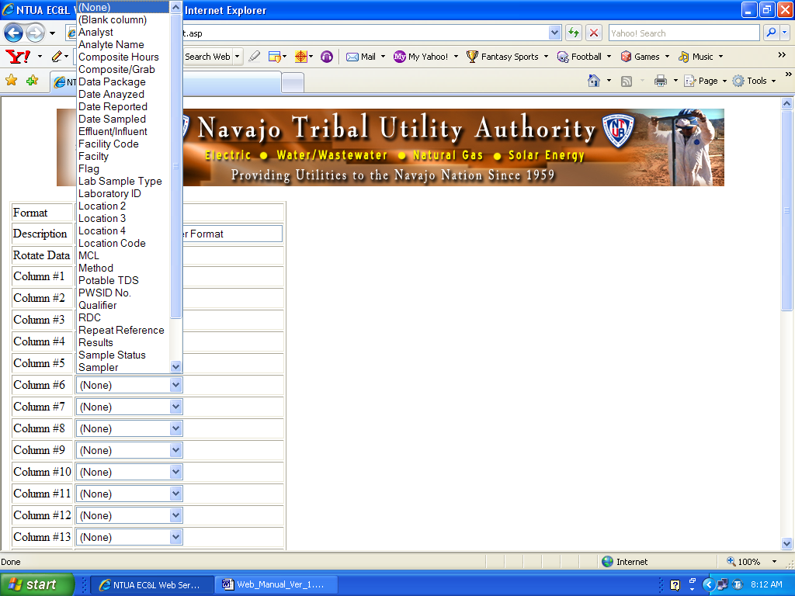

The rows named Column #1, Column #2, and so on are what will be displayed in your customized format. Each column has a drop down list of the fields that are available to be displayed. Select what you would like to be displayed for each column. Check the `Rotate Data` check box if you would like you data sorted in a column format.

Customized Formats

- Once you have decided which fields you would like displayed, click the `Save` button located at the bottom of the page. The fields selected for MARVIN DW are shown below.

Figure 21.
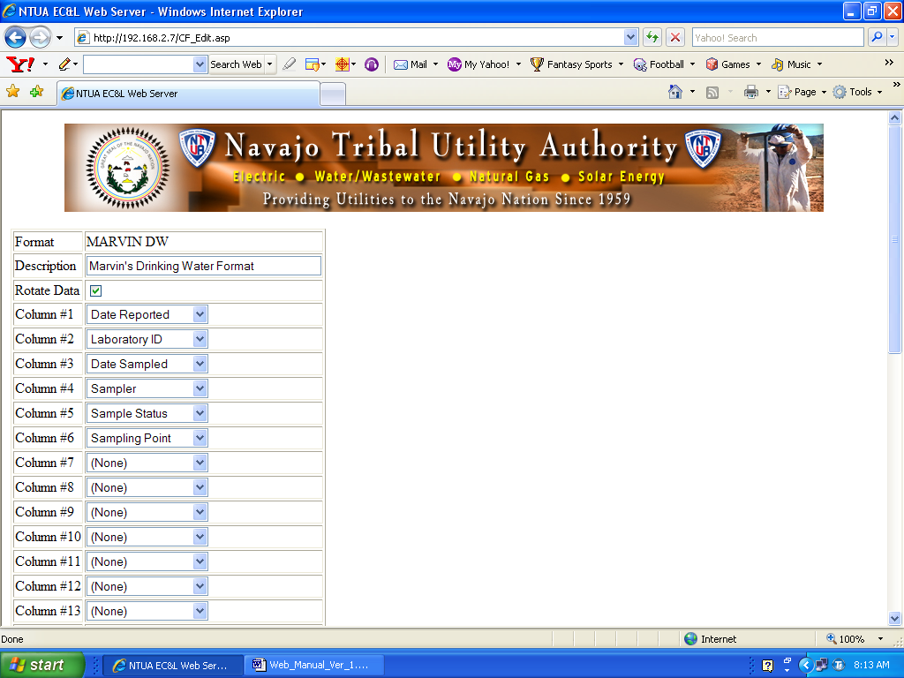
Customized Formats

Your customized format can now be used to view sample results. Figure 22 shows the new format available for use. The format `Description` you declared is what gets listed in the drop down list for your customized format.

Figure 22.
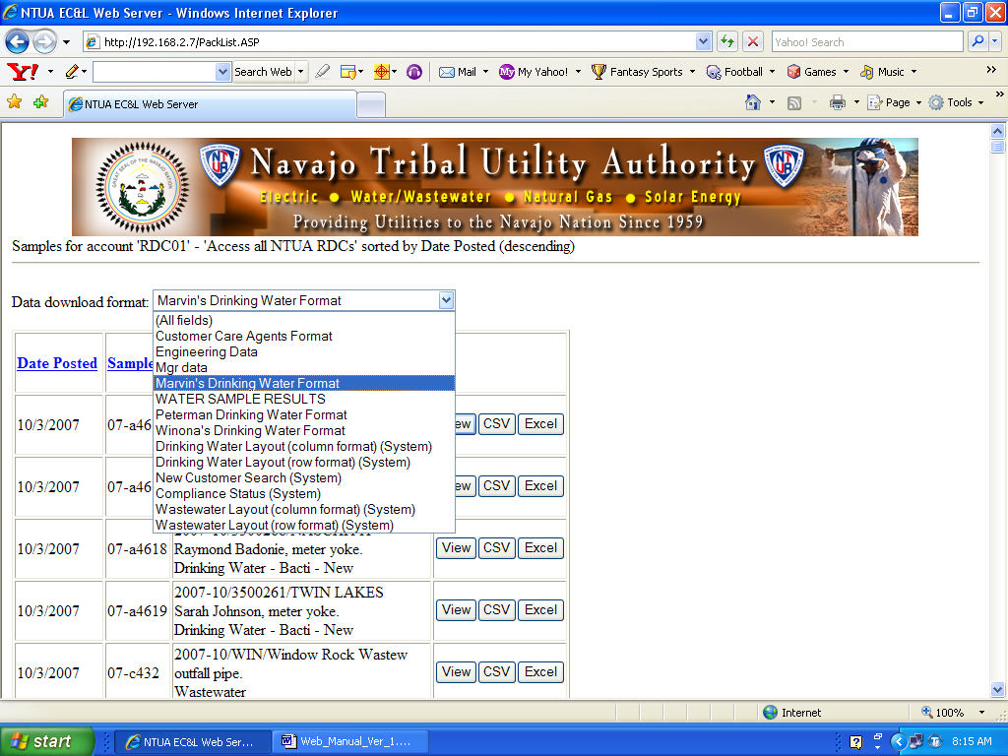

Customized formats are only available within the account it was created. System formats are available for use by all accounts.

Customized Formats

Figure 23 shows the layout for MARVIN DW in a column type format.

Figure 23.
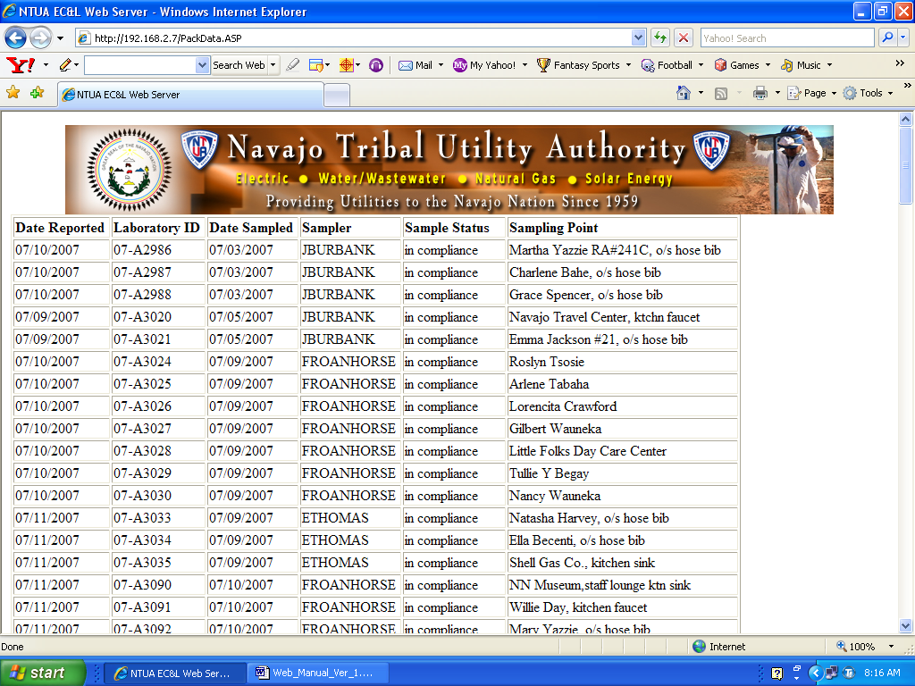

Customized Formats

To view and edit all formats under your account click the `List all formats` link. Figure 24 shows where the link is located.

Figure 24.
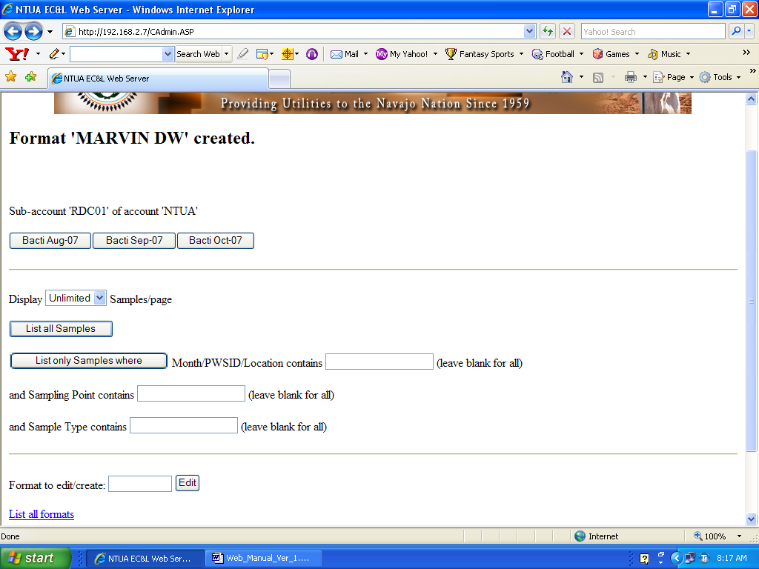

Customized Formats

Click on a format name to edit, view or delete the format. You should see a screen similar to Figure 25. If you have not created any formats there will be none listed.

Figure 25.
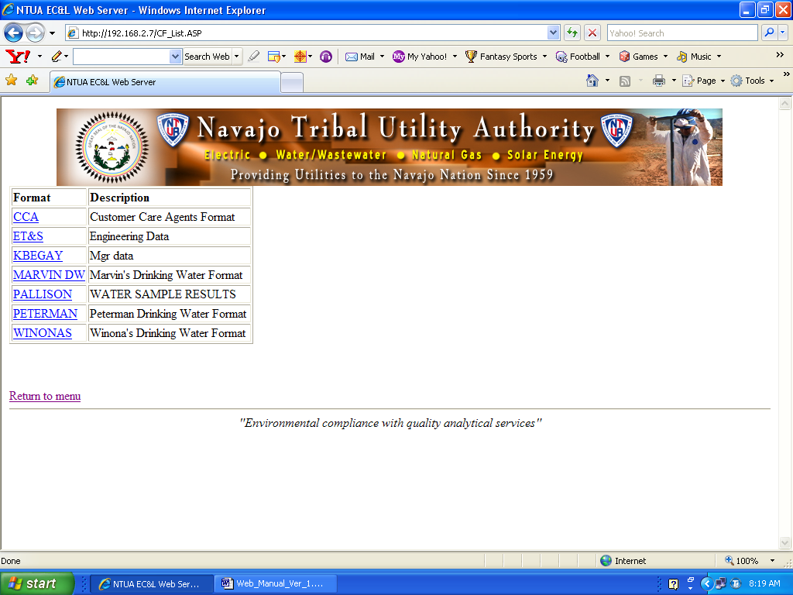

Logging Out of Your Account

To log out of your account simply close the web browser. For security purposes please do not disclose your Account ID and Password.

Appendix A

All column headings for sample demographics are listed here in alphabetical order.

 | Description
Analyst | Analyst who performed analysis or measurement.
Analyte name | Name of analyte.
Composite hours | Number of hours when composite sample was collected. Pertains to wastewater sample type.
Composite/grab | Composite or grab sample. Pertains to wastewater sample type.
Date analyzed | Date the analyte was analyzed or measured.
Data package | A code used by the LIMS Web Server to track samples uploaded to the web site.
Date posted | The date the sample results were posted.
Date reported | The date the sample results were reported by the analyst.
Date sampled | The date the sample was collected.
Effluent/Influent | Wastewater sample collection point with respect to wastewater facility.
Facility | Name of Facility. Pertains to wastewater sample type.
Flag | Will display `MCL Exceeded` only if MCL is exceeded.
Lab sample type | The type of sample matrix. Types are Drinking Water, Wastewater, or Special.
Laboratory ID | Also know as Sample ID. A unique Sample ID assigned by the laboratory for each sample.
Location 2 | A continuation of Sampling Point. Additional information relating to Sampling Point.
Location 3 | A continuation of Sampling Point. Additional information relating to Sampling Point.
Location 4 | A continuation of Sampling Point. Additional information relating to Sampling Point.
Location Code | The name of the water system or location where the sample was collected.
MCL | Maximum Contaminant Level.
Method | The method name used to carry out the analysis or measurement of an analyte.
Month/PWSID/Location | One of the five parameters used to sort sample results. The month has a YYYY-MM format. The PWSID accepts only the 7 digits from the EPA PWSID assigned to each water system. The Location is the same as the `Location Code`
Potable TDS | A Potable Total Dissolved Solids sample.
PWSID No. | Public Water System Identification (PWSID) Number assigned by the Environmental Protection Agency (EPA).
Qualifier | A parameter used to track if a sample is in acceptable condition. A sample will be rejected by the laboratory if it does not meet the this parameter.
RDC | Responsible District Code. A code used to track customer accounts at the NTUA Laboratory
Repeat Reference | Used to track samples that are labeled as `Repeats`.
Results | Sample results. Displays all analyte names related to the sample.
Sample | One of the five parameters used to sort sample results. Also known as Laboratory ID.
Sample status | A parameter specific to Bacti samples to determine if the results are “In Compliance” or “Out of Compliance”
Sample type | One of the five parameters used to sort sample results. Definitions for each sample type are listed in the `View Your Results` section of this manual.
Sampling point | One of the five parameters used to sort sample results. The format is: `Customer Name, point of collection`. Example, Willie Water, kitchen faucet.
Type of sample | Designates the samples as one of the following: new, routine, repeat, or other.
Units | The unit related to the analysis or measurement. Examples are: mg/L, ppm, kg.

